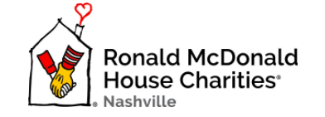

For more information contact:

Mikenzie Bartholomae

909-471-9402 mobile

bartholomaemikenzie@gmail.com

**Media Advisory**

Sept. 9, 2021

**HUSTLE FOR THE HOUSE**

**Ronald McDonald House 5K and Kathy Dungan 1-Mile Fun Run**

Members of the Nashville community are invited to attend the 5K and Kathy Dungan 1-Mile Fun Run on Saturday, Sept. 18, benefitting the Ronald McDonald House Charities of Nashville.

**What:** Race

**Who:** The Ronald McDonald House

**When:** Saturday, Sept. 18, 2021, starting at 7:30 a.m.

**Where:** Starting on Fairfax Avenue at 24th Avenue South

This year, the race will be offered in-person and virtually, ensuring that all who wish to are able to attend. The 1-Mile Fun Run will begin at 7:30 a.m., and the 5K will begin at 8 a.m. CT. Racers are encouraged to sport their finest disco attire for the run! Those who unable to run are invited to visit the nonprofit’s website and make a donation (https://rmhcnashville.com/).

# # #

The mission of Ronald McDonald House Charities of Nashville is to keep families close by providing essential resources and a “home-away-from-home” for families of critically ill children receiving inpatient or outpatient medical care at Nashville area hospitals.

**Ronald McDonald House Charities of Nashville**

2144 Fairfax Avenue, Nashville, TN 37212

615-343-4000, info@rmhcnashville.com

