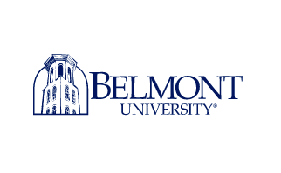 Contact: Mikenzie Bartholomae

Email: bartholomaemikenzie@gmail.com

Mobile: 909-471-9402

Follow-up News Release

Nov. 5, 2021

**Belmont University Celebrates New University President with a Carnival**

Belmont University staff and students took the day off, on Nov. 3, to celebrate the inauguration of the university’s new president, Gregory Jones. Throughout the week, the school offered students many ways to get involved in celebrating the new chapter in the school’s history.

On Wednesday, the university welcomed students onto the school’s main lawn for carnival games, food trucks, bungee jumping and even a Ferris wheel. The carnival, being that the students had the day off of class, was well attended by both staff and students. One student enjoying the festivities said, “not every school can say they had a Ferris wheel instead of class.” This event isn’t the only way Jones is making his mark on the campus though. Jones is a graduate and former dean of Duke university and champions the phrase “Let hope abound” as his mantra for the new school year with the goal of inspiring his campus to embrace this new season.

The previous university president, Bob Fisher, served the school for twenty-one-years. During that time, Fisher made a lasting impression on the students he encountered, often walking them to class and taking the opportunity to engage in a conversation to make sure they were adjusting well to Belmont or balancing their schoolwork alright.

It is no surprise that students will miss former president Fisher, but Jones brings with him a new chapter for the school, and it’s one the students seem excited to see. A senior student at Belmont said, when asked about the change to Belmont’s leadership, “Although the university will miss the leadership and presence of Bob Fisher, change is exciting, too.”

###

Belmont University sits in the heart of music city in Nashville Tennessee. The private liberal arts school instructs more than seven thousand students. The institution’s mission is to be a Christ-centered, student-focused community, developing diverse leaders of purpose, character, wisdom and transformational mindset, eager and equipped to make the world a better place.

**Belmont University**

1900 Belmont Blvd.

Nashville, TN 37212

615-460-6000